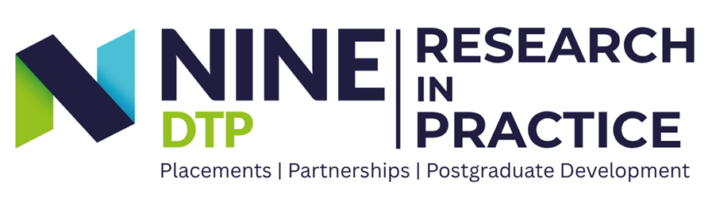Placement Host Expression of Interest

The Northern Ireland and North East Doctoral Training Partnership (NINE DTP) offers Research in Practice placements for postgraduate research students (PGRs). These provide opportunities for students to apply their research skills in a professional setting, typically over a three‑month period.
If you are interested in hosting a student, we invite you to share an outline of the type of opportunity you might offer. This does not need to be a fully defined project, we are looking for an indication of the work, environment, or themes a student could engage with.
This information will be used to build a portfolio of prospective host opportunities, which students can explore and follow up where there is a good match.

Guidance for host
This form can be used to share either a well-developed placement opportunity or an early-stage idea you’d like to explore with us. Please complete what you can, feel free to leave any unknowns blank or list possible options.

Section 1 – Host Organisation Information
Organisation Name:
Website (if available):
Brief description of your organisation’s work (e.g. mission, focus area):
Industry sector:
Main contact for the placement:
Name
Job title
Email
Phone (if preferred)
Primary location of placement: | ☐ Fully remote ☐ Hybrid ☐ On-site (site location):
Does your organisation have Employer Liability Insurance? | ☐ Yes ☐ No ☐ Not sure
Does your organisation have Public Liability Insurance? | ☐ Yes ☐ No ☐ Not sure
Does your organisation have a Health & Safety policy? | ☐ Yes ☐ No ☐ Not sure
How did you hear about NINE DTP and our placement scheme?

Section 2 – Placement Opportunity
Indicative placement title/theme (optional):
Outline of the opportunity: What sort of work could the PGR be involved in?
Context for the placement:
What area of work would the PGR be exposed to?
Potential activities (indicative, e.g. research, analysis, engagement, evaluation – this can be flexible and refined with the PGR)
Skills, interests or background that may be relevant (optional):
What kind of support/supervision could you offer? (e.g. team integration, mentoring, stakeholder events)
How would you prefer to proceed if a student expresses interest? | ☐ Informal initial conversation via email/teams  ☐ Request a short expression of interest from the student  ☐ Formal application/interview  ☐ I'm open to discussing the best approach with the NINE DTP team.
Do you have a particular/ideal timeframe in mind that would work well | ☐ Yes – please indicate:  ☐ This can be flexible

What happens next?
Return this completed form to: research.nine@durham.ac.uk
⬇
Your opportunity will be shared with students, who can explore and express interest where there is a good fit.
⬇
You’ll review interested candidates via application, informal conversation or interview, whichever suits you best (we’re happy to help facilitate)
⬇
Refinement of the placement details will happen in discussion with the host and the postgraduate research student
⬇
Before the placement begins, a short agreement will be signed by you and the postgraduate research student to confirm key details and gain NINE DTP approval
⬇
After the placement, we’ll invite you to complete a short feedback form to help inform best practice. Your details can remain visible to any other interested PGRs if you wish to host again.

