
Doctoral Training
Visually Mediated Research: Using Visual Methods in the Social Sciences
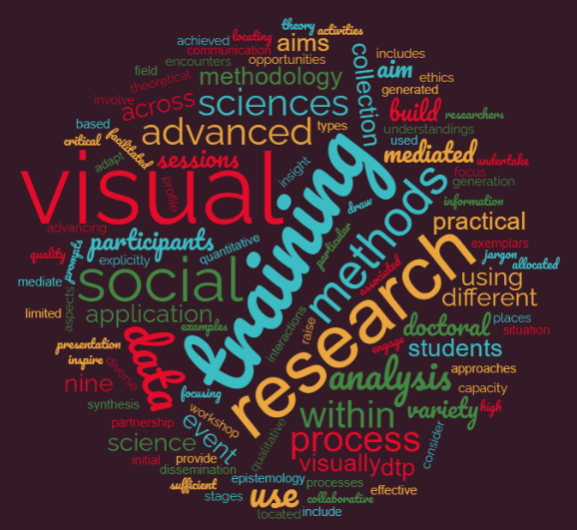
Full day in-person workshop delivered by Dr Pam Woolner and Dr Deborah Ralls at Newcastle University,
31st March 2026 – 9:30am-5pm.
We focus on the use of visual methods to mediate interactions and build understandings within social science research. We will consider different types of visual prompts and the processes associated with them; how they can be used within data collection, analysis and presentation stages of the research process.
The full day training event involves contributions from researchers who use visual activities and methods, focusing explicitly on different aspects of data collection, ethics, synthesis, analysis and dissemination. These sessions will draw on diverse examples from presenters’ research, locating the process of ‘visually mediated encounters’, and the data generated, within visual research methodology and social science epistemology. This training will provide jargon-free exemplars, both theoretical and practical, to engage and inspire participants from across the social sciences. There will be opportunities for participants to undertake practical application of the theory in workshop sessions using a variety of visual approaches to data generation, analysis and communication.
Places are limited to 50. You will be prompted to outline a brief case for attendance at point of registration (100-200 words introduction to your own research and particular interest in visual methods) . In the event that the course materials do not meet your criteria then the project team will notify you. Initial deadline 16th March 2026.
Cost
This workshop is free to students from Durham, Newcastle, Northumbria, Queens Belfast, Sunderland, Teesside and Ulster Universities. For other participants, the fee is £60 for PGRs, contracted ECRs, or contracted employees and £90 for other staff (email hass.pgtraining@ncl.ac.uk to arrange payment). This includes lunch and tea and coffee. This fee does not include accommodation or an evening meal.
How to book
Please complete the online registration via NINE DTP Inkpath. Already have a NINE DTP Inkpath login? Register via this link
If you don’t yet have access to NINE DTP Inkpath:
- visit https://webapp.inkpath.co.uk/
- select Northern Ireland North East DTP from the drop down.
- Register your account using your institutional email address.
- Once verified: Click on "Find” to browse and book available sessions.

