Covid-19 Studentship Extensions  This form applies to NINE DTP / NEDTC funded students | 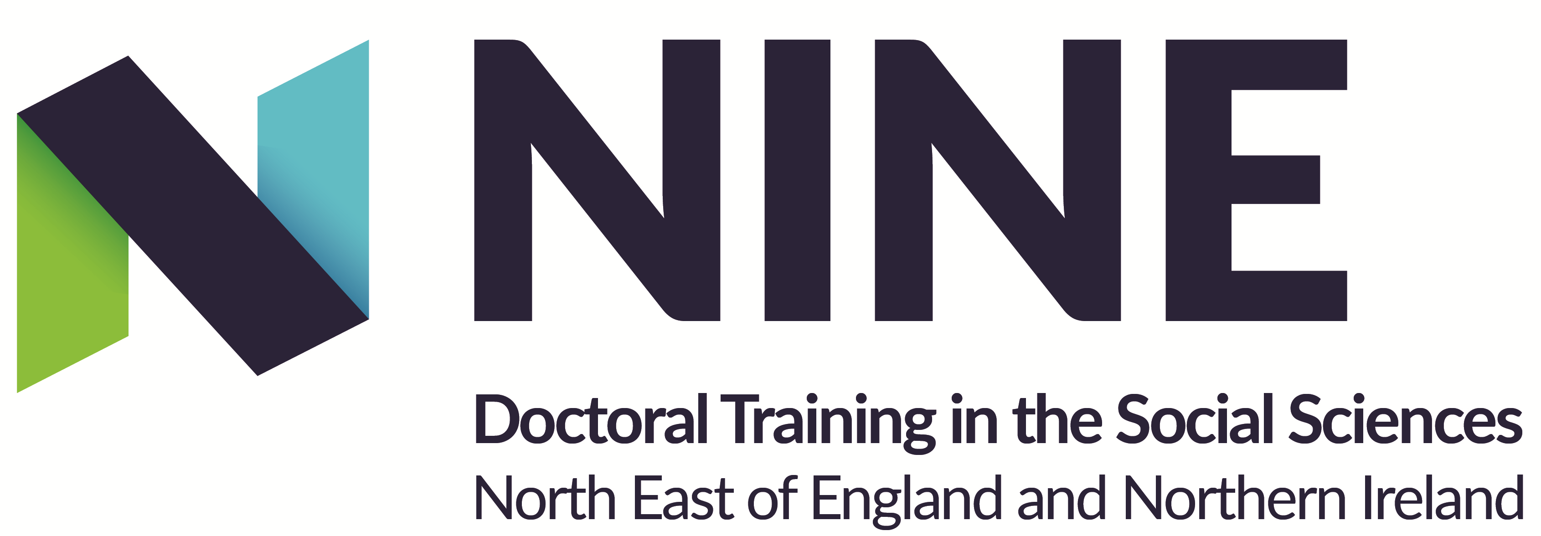
Candidates seeking to receive an extension to their period of funded study owing to the impact of the coronavirus pandemic on their studies should complete and submit this form around 6-8 months before the end of their period of funded study.

As a DTP we want all doctoral students to be able to complete their studies, and to be funded to do so. We aim to make sure that you are treated fairly, your personal circumstances are taken into account, and that decisions are made on a measured basis with as little paperwork as possible. Therefore, this form has been designed to minimise additional work for you and to collect all information in one place, but to also allow us to appropriately defend the allocation of additional public monies to provide additional support.

Please read the Guidance and Criteria before submitting your application.

Please submit the form between 6-8 months ahead the end of your period of funded study. Cases for extensions will not be considered if submitted earlier.

SECTION 1: to be completed by the award-holder
PERSONAL DETAILS
Name:
Student Number:
Institutional Email Address:
Institution: | Choose an item.
School/Department:
Primary Supervisor:
Primary Supervisor Email Address:
SECTION 2: PREVIOUS APPLICATIONS
Have you previously applied for a Covid-related extension from either NINE DTP or your institution
If yes, please indicate the duration of extension awarded | months, or weeks
In order to consider an application for an additional extension, NINE DTP will need to review your previous case for an extension in conjunction with your new case.

Candidates who have previously applied for an extension should present their previous application together with this application if they wish their case to be considered. You should submit this application alongside this form when presenting your case.
Impact of covid-19 on thesis:
Provide an explanation of the impact(s) the COVID-19 restrictions have had on your PhD: (500 words / half a page max). [In the case of applicants who have already sought a funded extension via one of the previous schemes, your case should build upon your previous statement.]
Mitigation:
Award-holders have been encouraged to adapt and adjust their project to mitigate the impact of the Covid-19 pandemic on their theses. Please provide details of any strategies and actions you have taken to mitigate the impact of the pandemic on your project, and whether these strategies have been effective. (300 words max.)
DECLARATION:
“I agree to a Panel to view the data I have provided in connection with my application. By signing this form, I am giving permission for all relevant staff to have access to this documentation.”
Award-holder Signature:
Date: | Click here to enter a date.
SECTION 3: SUBMISSION
Signature of Primary Supervisor:

The application should be named using the following convention:

Award Holder Surname + Initial_Host Institution_Extension_Date DDMMYYYY
e.g. SmithJ_DU_Extension_30062017

Please e-mail the completed, signed form to the
NINE DTP Administrator using the following email address: contact.nine@durham.ac.uk

Guidance

- Students should consider all types of impact upon their PhD completion (both direct and indirect impacts), including for example, access to facilities and the library, availability of workspace and an environment conducive to completing work, disruption to face to face testing or fieldwork sites, access to supervision, inability to travel to complete PhD research, significant caring responsibilities (and others).
- Please note, we date the start of the lockdown to Friday 20th March 2020.
- Extensions will be considered on a case by case basis by the DTP Directors in line with the UKRI guidance.
- We will only consider issues directly linked to covid-19 and for impacts on your PhD research and/or thesis writing (e.g. this is not a financial hardship fund). Applications based solely on ill health should be dealt with via sick leave procedures in the usual way (both physical and mental health). If your application combines ill-health with other impacts, please use this form.
- All students should have discussed how the current covid-19 pandemic might mean that alternative thesis plans are needed to allow a timely completion and submission. We would expect all applicants to be able to detail mitigation strategies they have employed, and would note that a financial extension should be considered as a secondary plan to mitigating impacts through potential changes to the thesis. Students should note that minor impacts upon the original thesis plans should be mitigated through the examination process.
- This funding is only to enable students to complete their doctoral work. It should not be used, for example, to provide additional resources to carry out more research beyond doctoral work or time for writing papers once doctoral work is complete. This funding extension is also not for compensating the difficulties of the current job-market.
- All award-holders should discuss the impact of covid-19 with supervisors and supervisors need to sign this form to acknowledge that this discussion has taken place.
- Under General Data Protection Regulation, the NINE DTP is required to obtain your consent for the Extensions Panel to view the data you provide. By signing and submitting this information, the award-holder is giving permission for all relevant staff to have access to their documentation.
- Award-holders will be notified of the decision by the NINE DTP Administrator.

Version Control
Version | 2.0
Last Amendment | 07/05/2021
Last Amended By | DR

