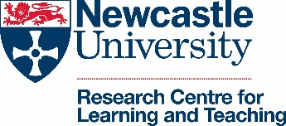
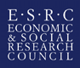 | NINE DTP  Northern Ireland and North East Doctoral Training Partnership

Doctoral Training Event

Visually Mediated Research: Using Visual Methods in the Social Sciences

NINE DTP collaborative Advanced Training

22-23 June 2020
Facilitated by Dr Pamela Woolner, Dr Jill Clark, Dr Helen Burns, Dr Eric Fletcher & Prof Elaine Hall
Aims
The main aim of this advanced training is to focus on the use of visual methods to mediate interactions and build understandings within social science research. We will focus on different types of visual prompts and the processes associated with them; how they can be used within data collection, analysis and presentation stages of the research process. We aim to raise the profile of visual methodology and build capacity across the social sciences in the effective use of this advancing field.
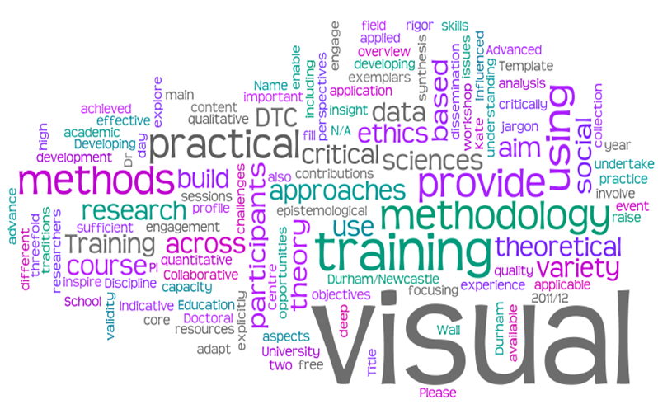
These aims will be achieved through a two day training event, which will involve contributions from a variety of researchers who use visual activities and methods, focusing explicitly on different aspects of data collection, ethics, synthesis, analysis and dissemination. These sessions will draw on diverse examples from presenters' research, locating the process of 'visually mediated encounters', and the data generated, within visual research methodology and social science epistemology. This training will provide jargon free exemplars of sufficient critical insight, both theoretical and practical, to engage and inspire participants from across the social sciences to adapt high quality visual methods to their particular research situation. There will be opportunities for participants to undertake practical application of the theory in workshop sessions using a variety of qualitative and quantitative based visual approaches to data generation, analysis and communication.
Costs
Places are limited to 65. They will be allocated through an application process, initial deadline 5th June 2019. This course is free to students from Durham, Newcastle, Northumbria, Queens Belfast, Sunderland, Teesside and Ulster Universities. For other students the course costs £60 for the two days. This includes lunch on each day and tea and coffee. This fee does not include accommodation or an evening meal.
Location
The advanced training will be located at Newcastle University.
FOR MORE INFORMATION:
https://www.ninedtp.ac.uk/training-opportunities/

